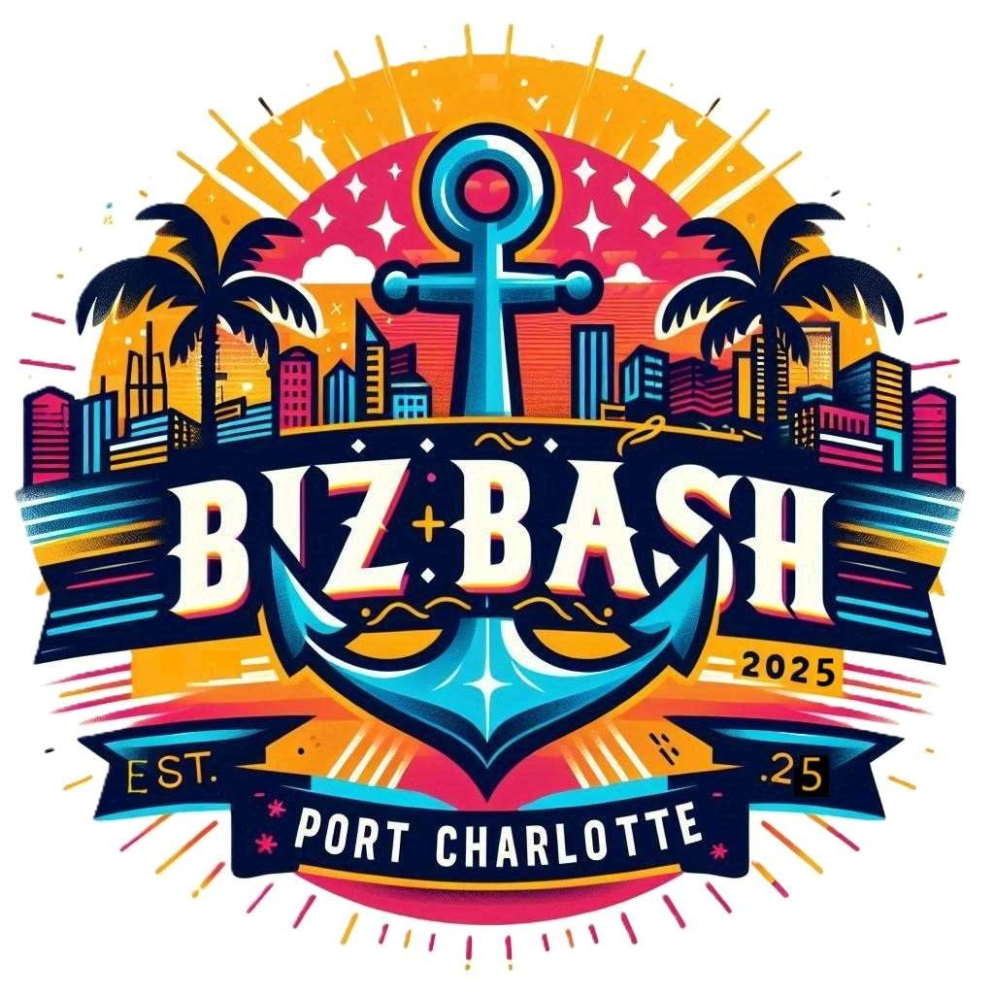

Dear Local Businesses,

I hope this letter finds you well. I am excited to announce an upcoming event that will showcase the diverse range of businesses in our community. "BIZ BASH" is set to take place on March 22, 2025, To ensure a wide representation of industries, we are limiting the number of businesses per industry, making it a fantastic opportunity to stand out and interact with potential customers from various backgrounds.

The purpose of BIZ BASH is to introduce the public to our local companies and provide them with an opportunity to connect with you in person. We believe that by bringing together businesses from different sectors, we can create a vibrant and engaging event that highlights the strength and variety of our local economy.

If you are interested in being an exhibitor or sponsor at BIZ BASH, please visit our website at www.bizbashpcfl.com to sign up. The cost for exhibitors is $299.00 for a 10x10 area, while sponsors can secure a 10x10 setup area for $1500.00. Multiple spaces can be purchased for those looking to maximize their presence at the event.

This event is not only a great opportunity for networking and exposure but also a chance to build relationships within our community. We encourage exhibitors to have a giveaway basket on their table, which will help you connect with local attendees and potentially develop lasting relationships.

BIZ BASH is also an excellent platform for snowbirds to reconnect with the local business community and discover new products and services right in their own backyard.

We believe that your participation in BIZ BASH will not only benefit your business but also contribute to the overall success of the event. We look forward to seeing you there and showcasing all that our local businesses have to offer.

Thank you for considering this opportunity to be part of something special. If you have any questions or need further information, please do not hesitate to contact us.

Warm regards,

Ramona Reiner

Event Coordinator

941-889-8464